**DC-1 NEW SCHEMAS REFRESHMENTS**

**NEW TABLESPACE: -**

**Create tablespace BAWDB_24 datafile '+DATA/BAWDB/DATAFILE/BAWDB_001.dbf' size 5G ;**

**CHECK ALL THE DATAFILE OF A TABLESPACE**:-

* SQL>

COLUMN file_name FORMAT A70;

SELECT file_id,

file_name,

ROUND(bytes/1024/1024) AS size_mb,

ROUND(maxbytes/1024/1024) AS max_size_mb,

autoextensible,

increment_by,

status

FROM dba_data_files

WHERE tablespace_name = 'BAWDB_24'

ORDER BY file_id;

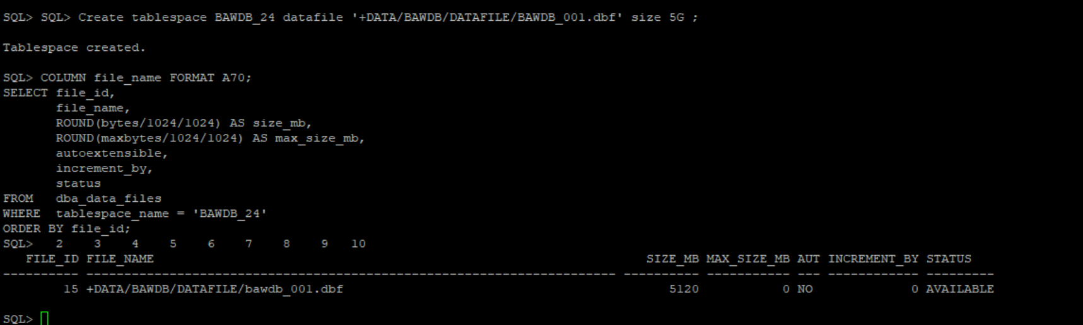

* SQL> SET PAGESIZE 140 LINESIZE 200;

SELECT tablespace_name,

size_mb,

free_mb,

max_size_mb,

max_free_mb,

TRUNC((max_free_mb/max_size_mb) * 100) AS free_pct,

ROUND((max_size_mb-max_free_mb)/max_size_mb*10,2) AS used_pct

FROM (

SELECT a.tablespace_name,

b.size_mb,

a.free_mb,

b.max_size_mb,

a.free_mb + (b.max_size_mb - b.size_mb) AS max_free_mb

FROM (SELECT tablespace_name,

TRUNC(SUM(bytes)/1024/1024) AS free_mb

FROM dba_free_space

GROUP BY tablespace_name) a,

(SELECT tablespace_name,

TRUNC(SUM(bytes)/1024/1024) AS size_mb,

TRUNC(SUM(GREATEST(bytes,maxbytes))/1024/1024) AS max_size_mb

FROM dba_data_files

GROUP BY tablespace_name) b

WHERE a.tablespace_name = b.tablespace_name

)

--where tablespace_name = 'USERS'

ORDER BY tablespace_name;

* SQL>

COLUMN file_name FORMAT A70;

SELECT file_id,

file_name,

ROUND(bytes/1024/1024) AS size_mb,

ROUND(maxbytes/1024/1024) AS max_size_mb,

autoextensible,

increment_by,

status

FROM dba_data_files

WHERE tablespace_name = 'BAWDB_24'

ORDER BY file_id;

* SQL>

SET LINESIZE 200:

SELECT tablespace_name,

block_size,

extent_management,

segment_space_management,

status

FROM dba_tablespaces

ORDER BY tablespace_name;

* SQL>

set pages 200;

select username from all_users;

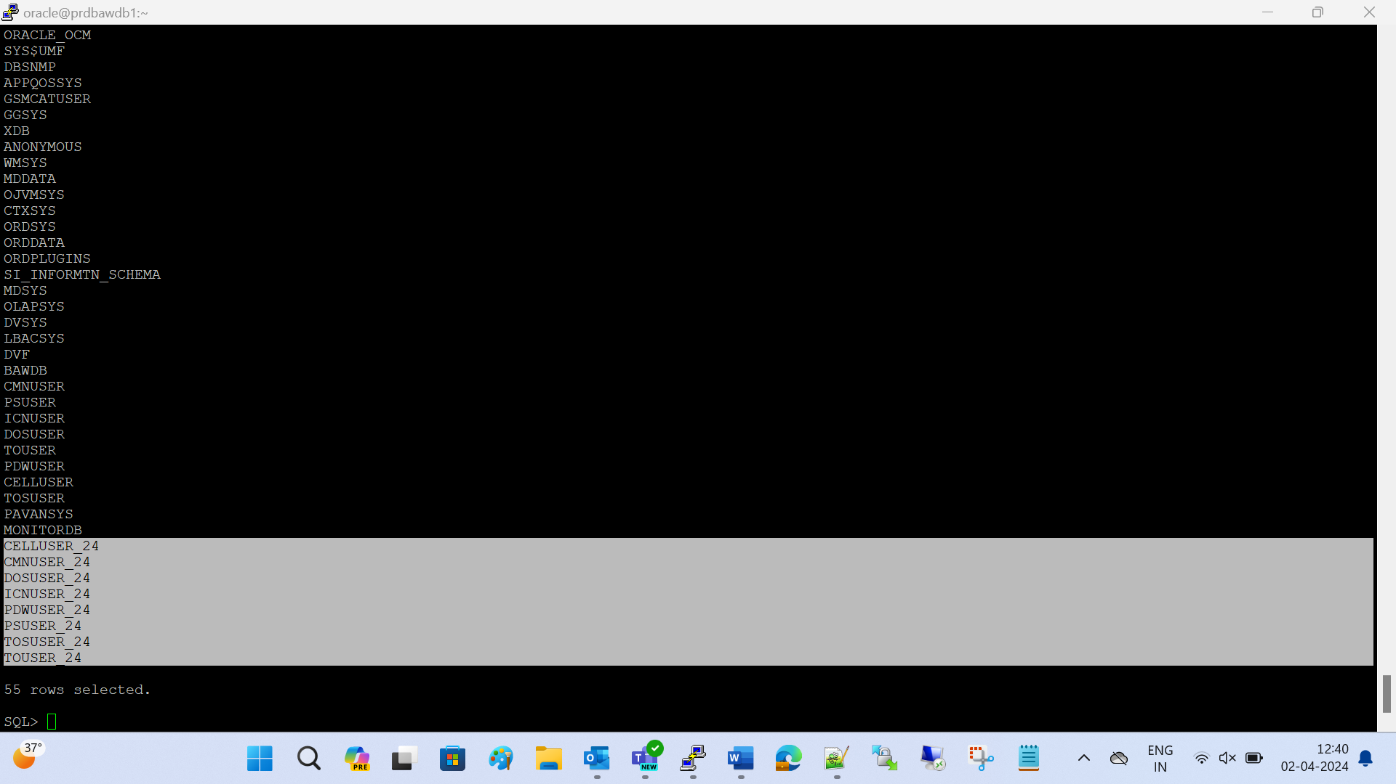

* SQL>

set lines 150 pages 150;

col OWNER for a30;

col DIRECTORY_NAME for a30;

col DIRECTORY_PATH for a30;

select owner,DIRECTORY_NAME,DIRECTORY_PATH from dba_directories;

SQL> set lines 200 pages 200;

col username for a25;

col profile for a20;

col DEFAULT_TABLESPACE for a20;

col TEMPORARY_TABLESPACE for a20;

col ACCOUNT_STATUS for a20;

select username,DEFAULT_TABLESPACE,TEMPORARY_TABLESPACE,PROFILE,ACCOUNT_STATUS from dba_users order by 1 ;

USERNAME DEFAULT_TABLESPACE TEMPORARY_TABLESPACE PROFILE ACCOUNT_STATUS

------------------------- -------------------- -------------------- -------------------- --------------------

ANONYMOUS SYSAUX TEMP DEFAULT EXPIRED & LOCKED

APPQOSSYS SYSAUX TEMP DEFAULT LOCKED

AUDSYS USERS TEMP DEFAULT LOCKED

BAWDB USERS TEMP DEFAULT OPEN

CELLUSER USERS TEMP DEFAULT OPEN

CELLUSER_24 BAWDB_24 TEMP DEFAULT OPEN

CMNUSER USERS TEMP DEFAULT OPEN

CMNUSER_24 BAWDB_24 TEMP DEFAULT OPEN

CTXSYS SYSAUX TEMP DEFAULT EXPIRED & LOCKED

DBSFWUSER SYSAUX TEMP DEFAULT LOCKED

DBSNMP SYSAUX TEMP DEFAULT OPEN

DIP USERS TEMP DEFAULT LOCKED

DOSUSER USERS TEMP DEFAULT OPEN

DOSUSER_24 BAWDB_24 TEMP DEFAULT OPEN

DVF SYSAUX TEMP DEFAULT LOCKED

DVSYS SYSAUX TEMP DEFAULT LOCKED

GGSYS SYSAUX TEMP DEFAULT LOCKED

GSMADMIN_INTERNAL SYSAUX TEMP DEFAULT LOCKED

GSMCATUSER USERS TEMP DEFAULT LOCKED

GSMROOTUSER USERS TEMP DEFAULT LOCKED

GSMUSER USERS TEMP DEFAULT LOCKED

ICNUSER WFICNTS WFICNTSTEMP DEFAULT OPEN

ICNUSER_24 BAWDB_24 TEMP DEFAULT OPEN

LBACSYS SYSTEM TEMP DEFAULT LOCKED

MDDATA USERS TEMP DEFAULT LOCKED

MDSYS SYSAUX TEMP DEFAULT LOCKED

MONITORDB USERS TEMP DEFAULT OPEN

OJVMSYS SYSTEM TEMP DEFAULT LOCKED

OLAPSYS SYSAUX TEMP DEFAULT LOCKED

ORACLE_OCM USERS TEMP DEFAULT LOCKED

ORDDATA USERS TEMP DEFAULT LOCKED

ORDPLUGINS USERS TEMP DEFAULT LOCKED

ORDSYS USERS TEMP DEFAULT LOCKED

OUTLN SYSTEM TEMP DEFAULT LOCKED

PAVANSYS USERS TEMP DEFAULT OPEN

PDWUSER USERS TEMP DEFAULT OPEN

PDWUSER_24 BAWDB_24 TEMP DEFAULT OPEN

PSUSER USERS TEMP DEFAULT OPEN

PSUSER_24 BAWDB_24 TEMP DEFAULT OPEN

REMOTE_SCHEDULER_AGENT USERS TEMP DEFAULT LOCKED

SI_INFORMTN_SCHEMA USERS TEMP DEFAULT LOCKED

SYS SYSTEM TEMP DEFAULT OPEN

SYS$UMF SYSTEM TEMP DEFAULT LOCKED

SYSBACKUP USERS TEMP DEFAULT LOCKED

SYSDG USERS TEMP DEFAULT LOCKED

SYSKM USERS TEMP DEFAULT LOCKED

SYSRAC USERS TEMP DEFAULT LOCKED

SYSTEM SYSTEM TEMP DEFAULT OPEN

TOSUSER TOSSA_DATA_TS TEMP DEFAULT OPEN

TOSUSER_24 BAWDB_24 TEMP DEFAULT OPEN

TOUSER USERS TEMP DEFAULT OPEN

TOUSER_24 BAWDB_24 TEMP DEFAULT OPEN

WMSYS SYSAUX TEMP DEFAULT LOCKED

XDB SYSAUX TEMP DEFAULT LOCKED

XS$NULL SYSTEM TEMP DEFAULT EXPIRED & LOCKED

55 rows selected.

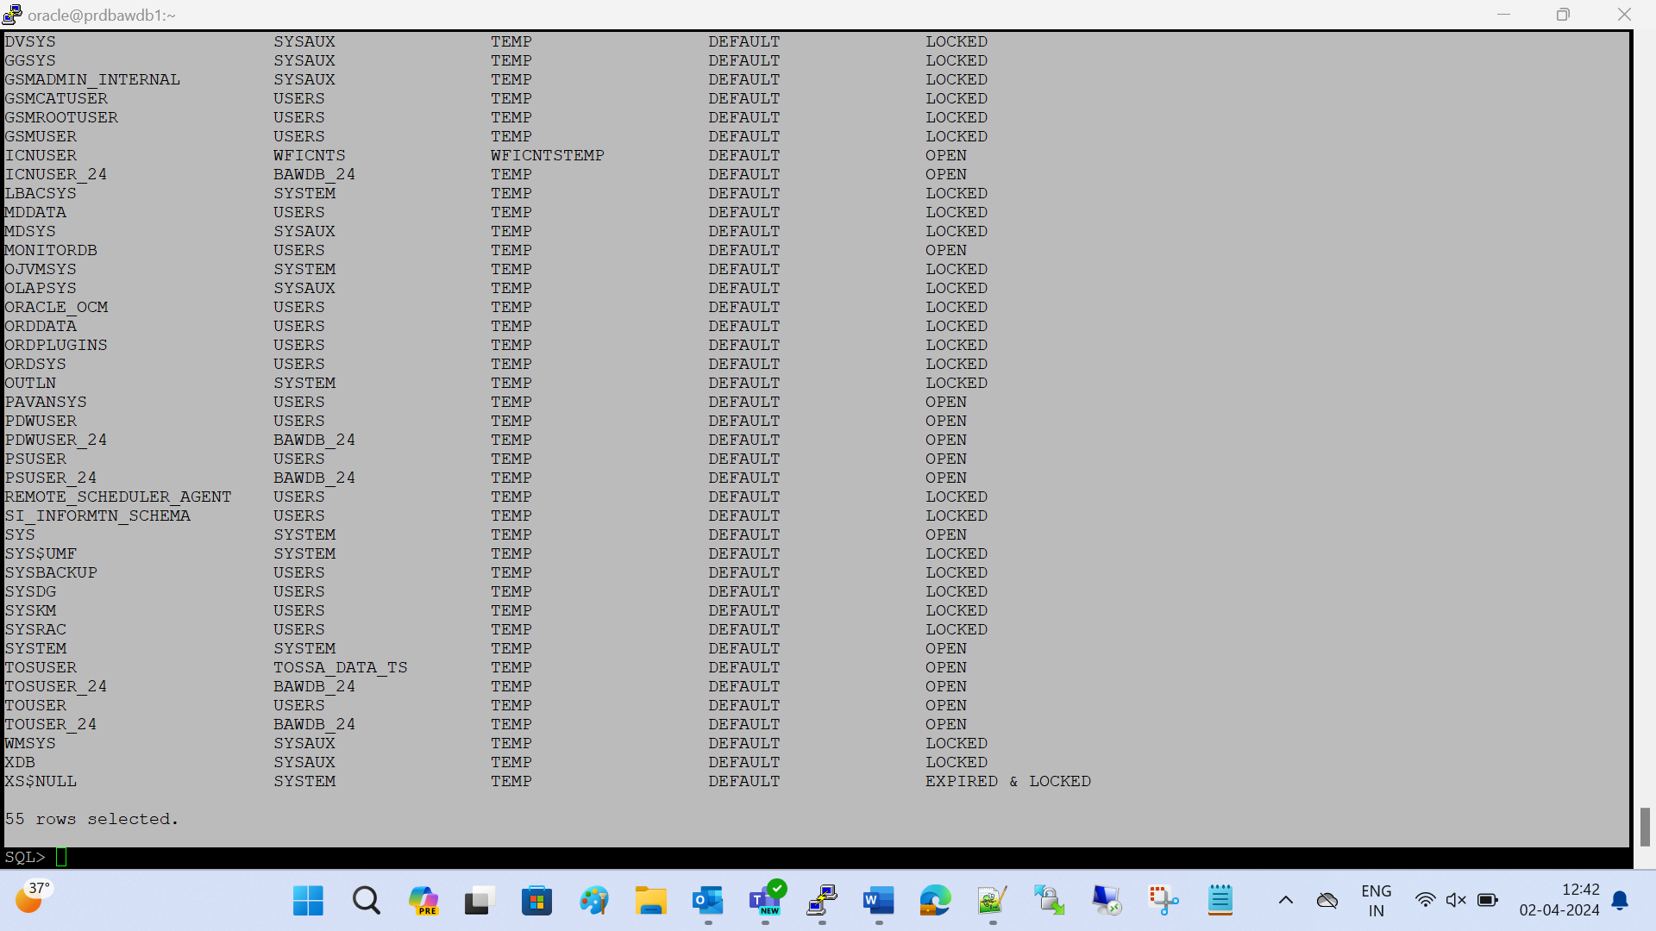

OWNER OBJECT_TYPE STATUS COUNT(*)

------------------------------ ----------------------- ------- --------

CELLUSER INDEX VALID 70

CELLUSER LOB VALID 8

CELLUSER SEQUENCE VALID 10

CELLUSER TABLE VALID 38

SQL> select owner,object_type,status,count(*) from dba_objects where owner in ('CELLUSER') group by object_type, owner,status order by owner;

OWNER OBJECT_TYPE STATUS COUNT(*)

------------------------------ ----------------------- ------- --------

CELLUSER INDEX VALID 70

CELLUSER LOB VALID 8

CELLUSER SEQUENCE VALID 10

CELLUSER TABLE VALID 38

SQL> select owner,object_type,status,count(*) from dba_objects where owner in ('CELLUSER_24') group by object_type, owner,status order by owner;

OWNER OBJECT_TYPE STATUS COUNT(*)

------------------------------ ----------------------- ------- --------

CELLUSER_24 INDEX VALID 69

CELLUSER_24 LOB VALID 8

CELLUSER_24 SEQUENCE VALID 10

CELLUSER_24 TABLE VALID 38

SQL> select owner,object_type,status,count(*) from dba_objects where owner in ('CMNUSER') group by object_type, owner,status order by owner;

OWNER OBJECT_TYPE STATUS COUNT(*)

------------------------------ ----------------------- ------- --------

CMNUSER INDEX VALID 687

CMNUSER TABLE VALID 204

CMNUSER VIEW VALID 35

CMNUSER LOB VALID 156

SQL> select owner,object_type,status,count(*) from dba_objects where owner in ('CMNUSER_24') group by object_type, owner,status order by owner;

OWNER OBJECT_TYPE STATUS COUNT(*)

------------------------------ ----------------------- ------- --------

CMNUSER_24 TABLE VALID 204

CMNUSER_24 LOB VALID 156

CMNUSER_24 INDEX VALID 678

CMNUSER_24 VIEW INVALID 35

SQL> select owner,object_type,status,count(*) from dba_objects where owner in ('DOSUSER') group by object_type, owner,status order by owner;

no rows selected

SQL> select owner,object_type,status,count(*) from dba_objects where owner in ('DOSUSER_24') group by object_type, owner,status order by owner;

no rows selected

SQL> select owner,object_type,status,count(*) from dba_objects where owner in ('ICNUSER') group by object_type, owner,status order by owner;

OWNER OBJECT_TYPE STATUS COUNT(*)

------------------------------ ----------------------- ------- --------

ICNUSER INDEX VALID 32

ICNUSER TABLE VALID 15

ICNUSER LOB VALID 7

ICNUSER SEQUENCE VALID 4

ICNUSER TRIGGER VALID 4

SQL> select owner,object_type,status,count(*) from dba_objects where owner in ('ICNUSER_24') group by object_type, owner,status order by owner;

OWNER OBJECT_TYPE STATUS COUNT(*)

------------------------------ ----------------------- ------- --------

ICNUSER_24 INDEX VALID 32

ICNUSER_24 SEQUENCE VALID 4

ICNUSER_24 LOB VALID 7

ICNUSER_24 TABLE VALID 15

ICNUSER_24 TRIGGER INVALID 4

SQL> select owner,object_type,status,count(*) from dba_objects where owner in ('PDWUSER') group by object_type, owner,status order by owner;

OWNER OBJECT_TYPE STATUS COUNT(*)

------------------------------ ----------------------- ------- --------

PDWUSER INDEX VALID 66

PDWUSER LOB VALID 8

PDWUSER TABLE VALID 23

SQL> select owner,object_type,status,count(*) from dba_objects where owner in ('PDWUSER_24') group by object_type, owner,status order by owner;

OWNER OBJECT_TYPE STATUS COUNT(*)

------------------------------ ----------------------- ------- --------

PDWUSER_24 TABLE VALID 23

PDWUSER_24 LOB VALID 8

PDWUSER_24 INDEX VALID 66

SQL> > select owner,object_type,status,count(*) from dba_objects where owner in ('PSUSER') group by object_type, owner,status order by owner;

SP2-0734: unknown command beginning "> select o..." - rest of line ignored.

SQL> select owner,object_type,status,count(*) from dba_objects where owner in ('PSUSER') group by object_type, owner,status order by owner;

OWNER OBJECT_TYPE STATUS COUNT(*)

------------------------------ ----------------------- ------- --------

PSUSER SEQUENCE VALID 6

PSUSER INDEX VALID 1190

PSUSER LOB VALID 305

PSUSER FUNCTION VALID 1

PSUSER TABLE VALID 369

PSUSER PROCEDURE VALID 10

6 rows selected.

SQL> select owner,object_type,status,count(*) from dba_objects where owner in ('PSUSER_24') group by object_type, owner,status order by owner;

OWNER OBJECT_TYPE STATUS COUNT(*)

------------------------------ ----------------------- ------- --------

PSUSER_24 INDEX VALID 1189

PSUSER_24 LOB VALID 305

PSUSER_24 PROCEDURE INVALID 10

PSUSER_24 TABLE VALID 369

PSUSER_24 FUNCTION VALID 1

PSUSER_24 SEQUENCE VALID 6

6 rows selected.

SQL> select owner,object_type,status,count(*) from dba_objects where owner in ('TOSUSER') group by object_type, owner,status order by owner;

no rows selected

SQL> select owner,object_type,status,count(*) from dba_objects where owner in ('TOSUSER_24') group by object_type, owner,status order by owner;

no rows selected

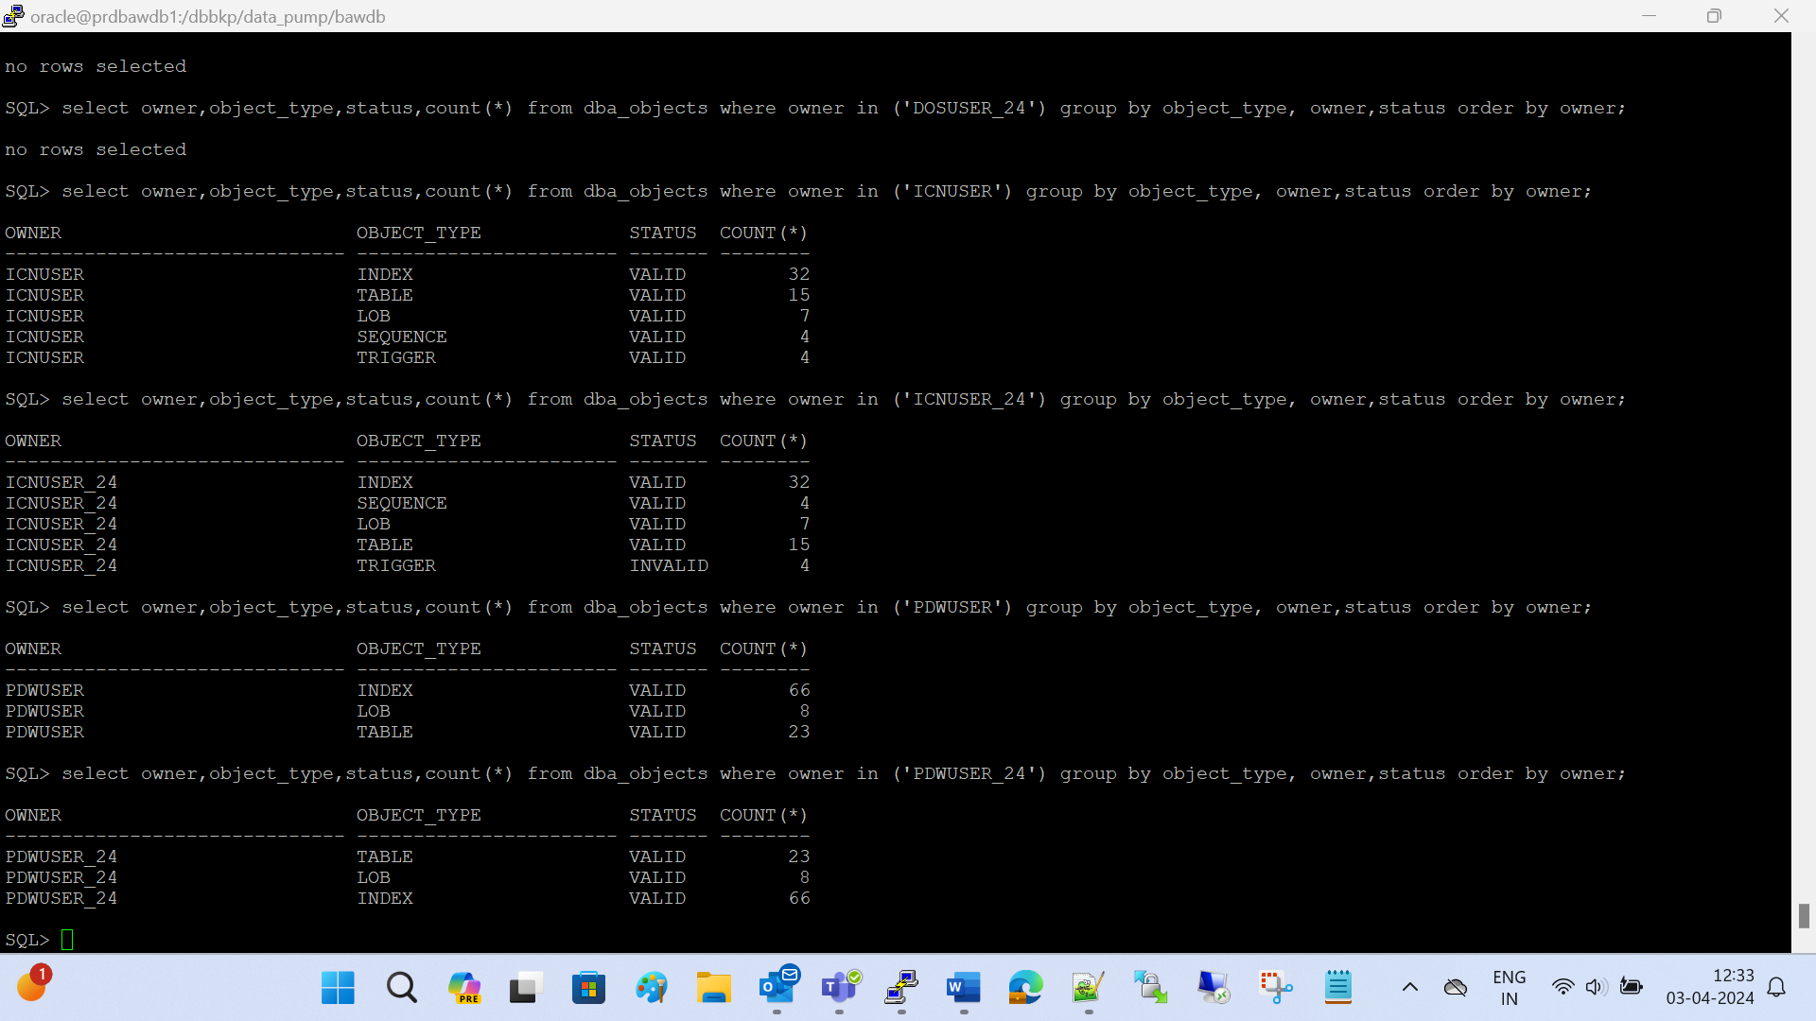

SQL> conn CELLUSER_24 / celluser123

Connected.

SQL> show user

USER is "CELLUSER_24"

SQL> conn CMNUSER_24 / cmnuser123

Connected.

SQL> show user

USER is "CMNUSER_24"

SQL> conn DOSUSER_24 / dosuser123

Connected.

SQL> show user

USER is "DOSUSER_24"

SQL> conn ICNUSER_24 / icnuser123

Connected.

SQL> show user

USER is "ICNUSER_24"

SQL>

SQL> conn PDWUSER_24 / pdwuser123

Connected.

SQL> show user

\USER is "PDWUSER_24"

SQL> conn PSUSER_24 / psuser123

Connected.

SQL> conn PSUSER_24 / psuser123

Connected.

SQL> show user

USER is "PSUSER_24"

SQL> conn TOSUSER_24 / tosuser123

Connected.

SQL> show user

USER is "TOSUSER_24"

